**Notes on our use of Epi-info for data extraction of the DCT studies**

**(Mohamed, Javier, Henrik; 23 January 2020)**

Contents

1. Introduction to Epi Info 2

1.1. Downloading Epi Info: 2

1.2. Installing Epi Info: 2

1.3. Before launching Epi Info: 2

1.4. Launching Epi Info for the first time 2

1.5. Launching Epi Info for the next times (Quick start) 3

1.6. Epi-info main structure 4

1.7. Navigation between forms 4

1.7.1. Downstream 4

1.7.2. Upstream 4

1.7.3. Expo (Exposing) variables (Read only i.e. for the purpose of display only) 5

1.8. Creating new records and navigation between entered records (within forms) 5

2. Filling in the forms 7

2.1. Study sheet (home page) 7

2.2. Trial sheet 8

2.3. Group sheet 13

2.4. Outcome sheets 17

3. References 22

# Introduction to Epi Info

In this document, I’ll go through each filed to clarify the questions and illustrate how we can answer each question and fill in the fields.

## Downloading Epi Info:

Epi-info is publicly available software from the CDC (Centers for Disease Control and Prevention) <https://www.cdc.gov/epiinfo/index.html> and can be downloaded through the following link: <ftp://ftp.cdc.gov/pub/software/epi_info/7/EI7_Setup.exe> .Unfortunately, Epi Info only supports Windows, so it won't run directly on Mac operating system.

## Installing Epi Info:

Installation of Epi Info is quite straight forward, so just follow the recommended installation options.

## Before launching Epi Info:

Make sure that you have 2 main files (attached in the email):

1. **DCT.prj:** project file that allows us to interact and enter the data (i.e. forms)
2. **DCT.mdb**: is the database where the entered data in .prj are stored

These 2 files should have the **same name and path** (i.e. they have to be in the same folder it will never work if they are in different folders).

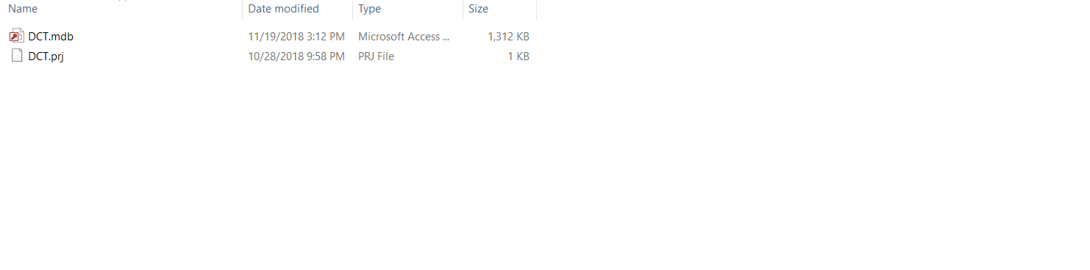

## Launching Epi Info for the first time

**1- Click Enter Data**

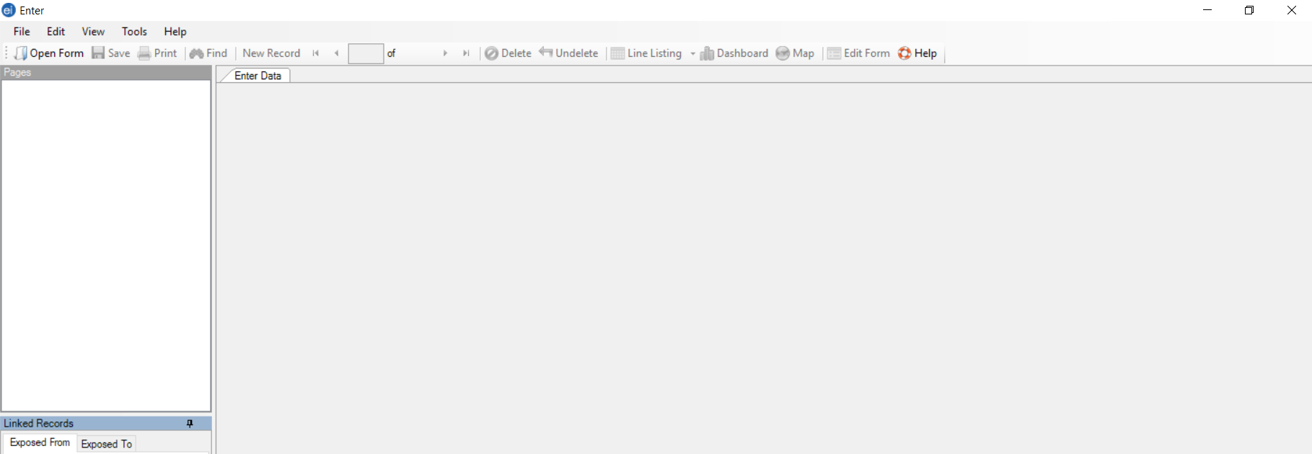**2- Open form**

**3- Browse to the folder where both .prj and .** **mdb exist, then select DCT.prj file**

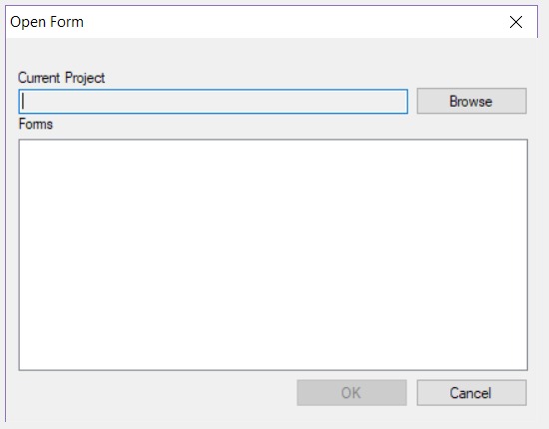

## Launching Epi Info for the next times (Quick start)

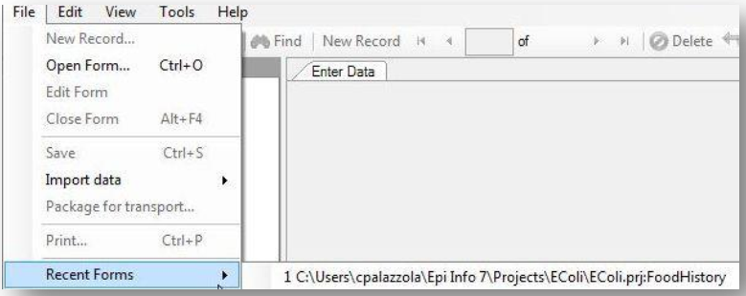For quick access to a project recently opened with the Enter module, use the Recent Forms option. From the toolbar, select **File** >>> Recent Forms

## Epi-info main structure

The data extraction form has **4 main sheets**:

1. Study
2. Trial i.e. when the study have more than one trial
3. Group i.e. the control and comparison treatment groups
4. Outcome i.e. prevalence, incidence and cure, each sheet has the name of its corresponding outcome on **the top center of the page**.

## Navigation between forms

### Downstream

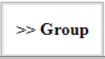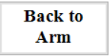

### Upstream

To go back we can use either the home or the back buttons of epi-info tool bar

* **Home:** move you back to the main page
* **Back:** move you back to the previous form, the main navigation path starts from the study>trial>group>outcome(PIC), so for instance if we are in the outcome sheet and we want to go back to the group sheet we just click back.



**Figure: Epi-info tool bar has many helpful and important buttons**

### Expo (Exposing) variables (Read only i.e. for the purpose of display only)

While we move from 1 sheet to another, we need to keep track of the study, trial, group and the outcome where we are. Therefore, in the **top left corner** of each sheet there is a gray box which shows the Study/group we are in.

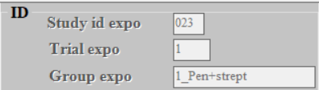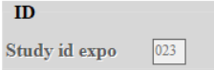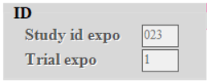

## Creating new records and navigation between entered records (within forms)

* **New record:** to create and add new records so you add more trials, groups. For the outcomes (PIC), new record allow you to add new entry for the outcome which may be due that the outcome was reported at more than 1 time point or if the outcome was reported in both quarter and cow units.
* **Save (Ctrl+S):** to save your entries before moving to the next form

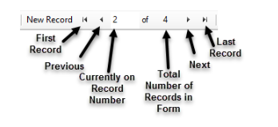

* **Counter in the blue oval**: using Save+ New record we can keep entering new entries but we need to keep watching the of the number of the new entries for instance if a study has only 2 groups we don’t need to go beyond 2.
* Right and left navigation arrows (red rectangle in the figure): allow to navigate between the entered records

**Other Epi-info tool bar buttons**

* **Print and Find** we may not need to use that much
* **Delete:** delete the record, the record would stay there but it would be marked as deleted and wouldn’t get out when we export the data sets
* Note: because some variable are required to be entered sometimes so the form won’t allow you to go back without filling in some data, so in this situation you need to close the form without saving the record and reopen it again. For instance, if inadvertently we clicked on one of the outcomes and we got in that outcome sheet so we can’t go back to the group sheet by clicking back

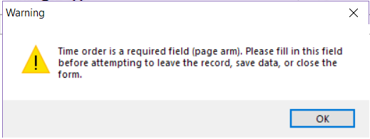

# Filling in the forms

## Study sheet (home page)

Study-level data are captured

|  |  |
| --- | --- |
| **Fields** | Caption |
| Study id | **Entries:** enter the id of the study you want to extract data from, you can find study ids in the bookmark of the pdf file you had |
| Country | **Entries:** a predefined list of countries  **Explanation:** The place where the study was conducted i.e. where the cows were staying not the where the authors form |
| General notes about the study (if needed) | **Entries:** e.g. lack of data availability, no denominators, data are only available in graph |

Note: entering the data form a list, you can click on the list and drop-down menu will pop-up and you can select the select the choice you want. However, it is easier to type the first 2 or 3 letter of the choice and it will pop-up directly e.g. you can type ca and Canada will show up directly



## Trial sheet

In the trial sheet, we abstract the data at study/trial level which are related to the treated cows, the exposure and methodological quality of the study.

|  |  |
| --- | --- |
| Name | Caption |
| ID |  |
| Study id expo | No enter, check variable to keep track of the study we are working on |
| Trial order | **Entries:** 1/2/3/4/…….  **Explanation:** This would almost always be 1 as most of the studies are essentially 1 trial. However, for studies having more than 1 trial, we can enter them one by one, you need to follow the sequence they were reported in the original study, e.g. 1 for the first reported trial, 2 for the second …etc |
| Trial design | **Entries:** RCT/NRSI (a non-randomized study of interventions)  **Explanation:** Recall that the NRSI type includes:  •**Observational studies** (cohort and case-control studies),  •**Quasi-randomized studies** in which the allocation method, as reported by the authors, was deterministic and did not reflect a formal random process (e.g. alternative animal identification numbers, days of the week, birth information, gate cutting); note that we should consider both of the following situations as of type NRSI: studies without any description of the allocation method and not labeled as a randomized study; studies with a “failed” randomization where an attempt was made to account analytically for important imbalances between intervention groups. |
| Study’s objective | **Entries:** Analysis of risk factors/ Superiority trial/ Equivalence trial/ Non-inferiority trial/ Assessing the effect of the Tx/ Tx_effect and RF/ Others/  **Explanation:**   * **For those studies without a clear hypothesis** (Superiority /Equivalence /Non-inferiority) about their treatment effect, you can select Assessing the effect of the Tx. * For those studies that assess Tx. Effect as one of the risk factors >>> Analysis of risk factors * For those studies that their main focus is mainly to assess Tx. and other risk factors >>> Tx_effect and RF |
| Cow’s info |  |
| Intervention allocation unit | **Entries:** Herd/ Cow/ Quarter  Tot No of farms selected for inclusion  Tot No of cows selected for inclusion  Tot No of quarters selected for inclusion |
| Tot No of farms selected for inclusion | **Entries:** ###  **Explanation:**   * These refer to the total number of farms, cows, and quarters enrolled/recruited and assigned for the treatment groups. * e.g. 223 Q from 123 C from 12 farms, * Confusion may arise in a situation where 123 cows were recruited but when it comes to assigning tx some quarters were unhealthy, have teat end callosity or ……., so the tx were applied only on 223 Q. So the number of cows= 132, and number of quarters = 223. * Note that depending on the reporting of the study, we may not have to fill all the three numbers, for instance if a study that didn’t report the number of herds included and reported only the number of cows, so we would abstract only the number of cows. |
| Tot No of cows selected for inclusion |
| Tot No of quarters selected for inclusion |
| Parity (average) | **Entries:** ###  **Explanation:**   * Copy-paste whatever mentioned: average, min and or max, depending on what was reported in the study not essentially all values. * What if the study reported that min lactation was 1 till 3 or more, because these fields accept only numbers; however, we can extract these information in the text box textbox “Cows Inclusion Exclusion criteria” |
| parity min |
| parity max |
| Breed | **Entries:** Holsteins/ Jerseys/ Holst-Jerseys Mix/ Holsteins+Other breeds/ Jerseys+Other breeds/ Brown Swiss/ Norwegian Red/ Not-reported/ |
| Cows Inclusion Exclusion criteria | **Entries:** copy and paste other important characteristics e.g. average length of the dp, scc at drying-off, average milk production at drying-off  split your entries for the different characteristics by (*Enter) e.g.  average DP = 55.5 /  average MP per cow/day = 17.49 kg  we are not expecting that all reviewers will catch the same information and in the same way (same capturing), but most importantly is to get the text in an organized way split by (*Enter) |
| Exposure |  |
| Type of exposure | **Entries:** Natural IMI/ Experimental IMI/ Natural-Experimental mix |
| Challenge Bacterial Spp | **Entries:** Staph. Aureus/ Strept. (all Sp.)/ Staph-Strept mix/ E-coli/ Others/ Not-reported |
| Challenge dose | **Entries:** ### |
| Bacterial Conc CFU/ml | **Entries:** ###  Type of exposure  Challenge Bacterial Spp  Challenge dose  Bacterial Conc CFU/ml |
| Methodological quality Items | |
| Was an apriori sample size calculation reported | **Entries:** Yes/No |
| If the data have some kind of hierarchical structure have the authors accounted for clustering in their analysis | **Entries:** Yes/No/ Data don’t have hierarchical structure  **Explanation:**   * **Data don’t have hierarchical structure** >>> simple analysis on the cow level * **Yes** >>> Random cow/herd effects, GEE, robust SE * **No** >>> no adjustment for clustering |
| Was the analysis done as intention to treat? | **Entries:** Yes/No/ No information  **Explanation:** just as reported by the authors  **Yes** >>> if the analysis was done as ITT: All randomized subjects included in the analysis and analyzed as randomized.  **No** >>> Complete-case (CC) and Per-protocol (PP) analysis, if the analysis excludes subjects with missing data  **No information** >>> if the authors failed to report theses information |
| Do you consider the methodology used for measuring the outcome as inappropriate?  If yes, please elaborate | **Entries:** Yes/No  **Explanation:**  This question thought to be important as we could capture serious concerns regarding the outcome measurement. We could think about whether the authors have **reported using or following** any of the standard international lab. techniques, e.g. NMC or IDF (International Dairy Federation).  **Example of answering with “Yes**  - Sampling and bacteriological examination of the milk were carried out according to IDF recommendations (IDF, 1981) …**(Berry & Hillerton, 2007).**  - One sample from each set of duplicate milk samples from individual quarters was thawed and, while still cold, 0.1 ml was plated onto MacConkey agar and Factor agar using sterile cotton tipped swabs (N.M.C., 1999). A 0.1-ml inoculum volume was used to improve sensitivity (Buelow et al., 1996; Lam et al., 1996; N.M.C., 1999) **(Godden et al., 2003).**  However when authors fail to report any of the standard guidelines we would have some concerns regarding the outcome measurement as an example is the study conducted by  **Molina et al. (2017).** |
| Were CM cases that might occur during dry period excluded from sampling post-calving? | **Entries:** Yes/No/ No information/No CM cases have been reported  **Explanation:**  During dry period, some cases of clinical mastitis may occur and in some articles these cases were culled and excluded from sampling post-calving so the answer would be “**Yes**”. However, in other articles, clinical mastitis detected during dry period have been treated (in the middle of the dry period may be with same or different tx that was used at drying-off) and they were sampled post calving, so the answer would be “**No**”. “**No information**”, if it wasn’t clear if CM cases were kept or excluded form sampling post-calving. |
| Secondary outcome was reported | Tick box for articles where Secondary outcomes e.g. scc or CM are reported |

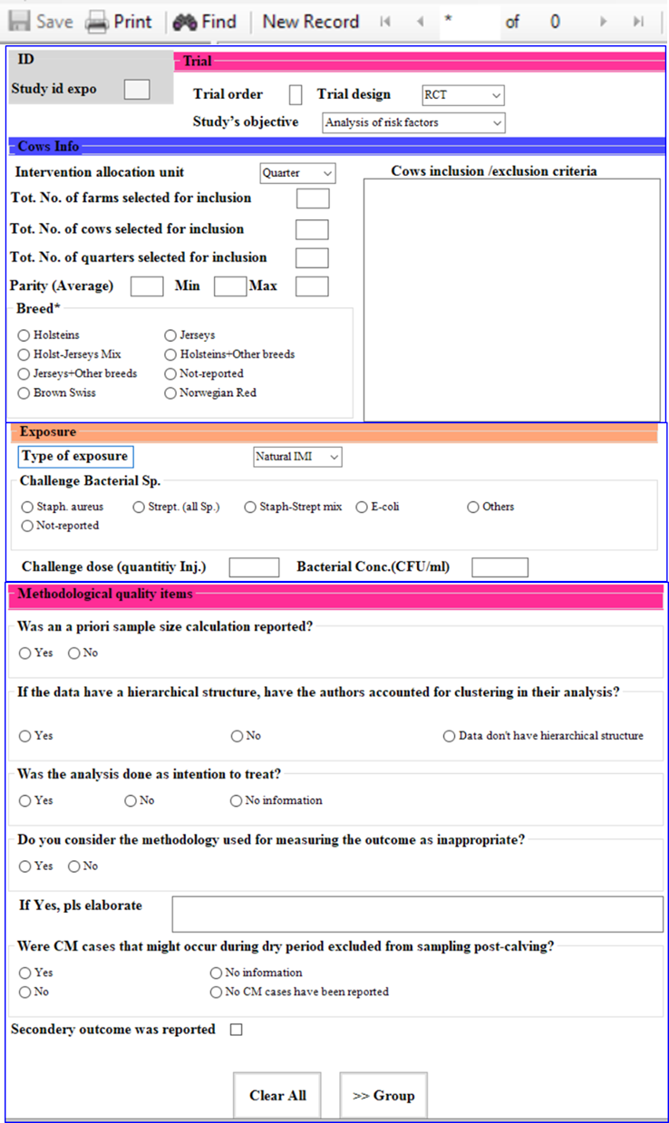

**1-** Verify that you are entering the trial information for the designated study

**2-** Start with filling in the data for first trial 1

**4-** If you have many trials per study you can keep adding them one by one through a cascade of **save** and **new record**

**5- While entering keep** watching the counter of the number of the entered trials don’t go beyond the number of trials reported in the study

**6-** Navigate through the entered trials and go back to the **1st trial** the has been entered and the go to **Groups** to enter the Tx groups for that trial

**3-** After filling in the form, if you have only 1 trial you can directly move to groups

**3-** After filling in the form, >>> Save (Ctrl + S) move to groups

## Group sheet

In the group sheet, we enter the data related to the antimicrobial/teat sealant used.

|  |  |
| --- | --- |
| ID |  |
| Study id expo | No enter, check variable to keep track of the study we are working on |
| Trial expo | No enter, check variable to keep track of the trial we are working on |
| Group |  |
| Group order | **Entries:** 1/2/3….for entering groups, we don’t have to follow a specific order, so it is up to the reviewer. |
| Active ingredient | **Entries:** list of predefined active ingredients e.g.Cefquinome, Ceftiofur, Cephalexin+Neomycin, Cephalonium, Cephapirin, Cloxa…..  **Explanation:** please pick form thelist, note that Placebo, -ve, control and TS only are also part of the list. |
| TS | **Entries:** tick box if TS was used in combination with Ab |
| Ab info |  |
| Concentration per dose | Entries: ##  **Explanation:** concentration of AB per infusion or per injection. Note for combination of AB e.g. Naficillin+Pen+Strept or Framycetin+Penethamate hydroiodide+penicillin the concentration for the 3 ingredients can be captured in the textbox e.g. “IMM tubes containing 110-mg sodium nafcillin, 300-mg procaine benzylpenicillin and 125-mg dihydrostreptomycin (Vetipen DC; Vetimex B.V., Bladel, the Netherlands) administered to all quarters once” |
| Administration regime | **Entries:** Selective/Blanket  Explanation:  **Selective**>>> cows were treated based on some selection criteria  **Blanket** >>> all quarter of all cows |
| Selection criteria (if the Ab was administered on selective basis) | **Entries:** Petrifilm/ Lab. culture/ SCC/ CMT/ Previous mastitis history/ NAGase/ More than one criteria  Explanation: - |
| AB preparation | **Entries:** Commercial/Experimental  Explanation: - |
| AB trade name (if it was **commercial**) | **Entries:** Copy and paste the Trade name e.g. Orbenin D.C., Nafpenzal D.C., Cepravin D.C., DryClox DC Xtra, Vetipen DC  Explanation: - |
| Frequency of administration | Entries: ##  **Explanation:** some preparation administered at once at drying-off so the frequency would be 1, others may be administered twice, or more, so the frequency would be 2,3,4… |
| Interval (days) | Entries: ##  **Explanation:** days between infusions if the AB was administered more than once |
| Route | **Entries:** Intra-mammary/ IM/ SC/ IV/ Topical/ Oral  Explanation: - |
| TS info |  |
| Ts Conc. | Entries: ##  Explanation: - |
| TS preparation | **Entries:** Commercial/Experimental  Explanation: - |
| TS active ingredient | **Entries:** Pick from the list  Explanation: - |
| Ts trade Name | **Entries:** Copy and paste the Trade name in the same way as we did in AB  Explanation: - |
| More drug info. (copy/paste) | **Entries:** copy and paste active ingredient characteristics e.g.” (AB; 250 mg of cephalonium, Cepravin Dry Cow, Intervet Schering-Plough Animal Health, Milton Keynes, UK)”  Explanation: - |
| Role in PICO |  |
| PICO1-2 | Illustrative example for using PICO questions   |  |  |  |  |  | | --- | --- | --- | --- | --- | | # | Group | PICO 1-2 | PICO3-4 | PICO 5 | | 1 | Control | 0 | - | - | | 2 | Clox+TS (blanket) | 1 | 0 | 1 | | 3 | Clox (blanket) | 1 | - | 0 | | 4 | Nova+TS (blanket) | 1 | - | 1 | | 5 | Nova (blanket) | 1 | 0 | 0 | | 6 | Clox+TS (selective) | - | 1 | - | | 7 | Nova (selective) | - | 1 | - |   0 = control, 1 =treatment, and - = not used for that PICO |
| PICO3-4 |
| PICO5 |
| Quality of administration technique | |
| Teat preparation before DCT infusion | **Entries:** Yes/ No/ Not-reported  Explanation:   * **Yes** >>> wipes the udder with alcohol-moistened wipes or towels * **No** >>> No * Not-reported>>> if neither were reported. |
| Depth of insertion of DCT syringe cannula | **Entries:** Full/ Partial/ Not-reported  Explanation:  Sometimes the depth of insertion is reported clearly in the article e.g. “The dry cow treatments were infused using a partial insertion technique”. Or in the basis of the length of insertion e.g. “About 3 mm of the cannula was inserted into the teat canal”.   * **Partial** >>> Partial insertion of the treatment syringe cannula only 3 mm (1/8 inch) * **Full** >>> full insertion when it goes beyond that limit, other phrases indicate full insertions e.g. DCT was infused into the teat sinus, into the teat cistern of each quarter * **Not-reported** >>> if neither were reported.   For more details about insertion techniques pls review: <https://www.medvet.umontreal.ca/rcrmb/en/page.php?p=79&tm=i> |
| Teats pray or dipping after DCT infusion | **Entries:** Yes/No/Not-reported  **Explanation:** For example, “After dry cow therapy was administered, teats were postdipped with 1.0% iodine with 10% emollient (Della Barrier, DeLaval, Kansas City, MO)” |

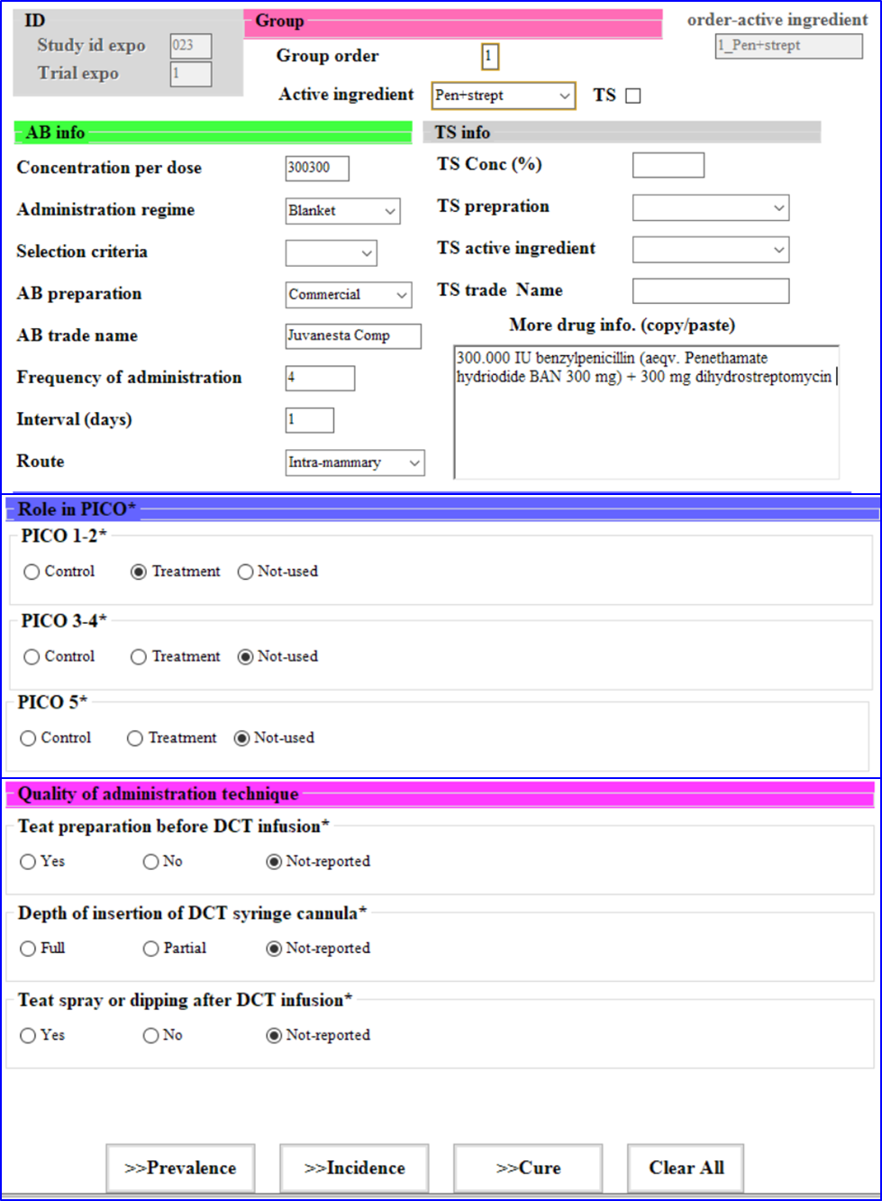

**1-** Verify that you are entering group info for the designated trial in that specific study.

We don’t want to put groups that are not existing in the study or trial

**2-** Start with filling in the form for the first group

## Outcome sheets

* We are extracting data for three main outcomes: prevalence, incidence and cure (PIC) at three independent forms, all the of the three forms have the same structure i.e. the same variables except for the title where each form has its corresponding outcome.
* We are extracting 2 main kinds of data:
* Row data (counts/ frequencies) number of +Ve and total for each treatment group **(i.e. Arm-based data)**
* Adjusted estimates or coefficients obtained from multivariable models(i.e. Contrast -based data)
* Note, when both row data and adjusted coefficient are present, we need to extract both in 2 independent tables i.e. (Arm and Contrast). If data obtained from univariable analysis and row data are available, the priority is for the row data.

|  |  |
| --- | --- |
| ID |  |
| Study id expo | No enter, check variable to keep track of the study we are working on |
| Trial expo | No enter, check variable to keep track of the trial we are working on |
| Group expo | No enter, check variable to keep track of the group we are working on |
| Outcome _info |  |
| Def | **Entries:** Copy and paste the definition  **Explanation:** For example, “IMI was considered cured when a previously identified pathogen was not cultured in any of the samples collected on the subsequent 3 sampling days (within 24 hours after calving and 15 and 30 days after calving).”. Another example, “A mammary quarter was diagnosed as cured if: 1) at least 3 of 4 postpartum samples were cultured, 2) the fresh sample was not missed, and 3) the same pathogen isolated at dry-off was not cultured in any postpartum sample.”.  **Note: we can only do that for the 1stly entered group, instead of keep doing that in each entered group.** |
| Detection Method | **Entries:** Culture/ SCC/ PCR  **Explanation:** The method used for detecting IMI |
| COV (1000cells/ml) | **Entries:** ###  **Explanation:** cut -off value that was used for defining cows/quarter with IMI e.g. 200 or 150 for those articles that define IMI on the basis of SCC e.g. “>150,000 cells/mL at the first post-calving herd test, so the COV = 150”. |
| Stratifying variable | **Entries:** No-stratification (totals)/ Parity/ Breed/ Length of the dry period/ Others  **Explanation:** If the results were reported as stratified by another variable, so we can select the stratifying variable from the list and fill in the different levels of the variable in stratification levels (see below) |
| Time info |  |
| Time order | **Entries:** 1/2/3….  **Explanation:** For entering results at different time points, e.g. bacteriological culture results obtained at 14-days and 20-days post calving in case they were reported separately. For time order, we need to follow the sequence by which the results were presented, so we need to enter the results for 14 days post calving first and then 20 days post-calving.  The confusion may arise when, two post calving milk samples were taken and reported as one in a combined way using parallel or series interpretation. |
| Days postcalving | Entries: ##  **Explanation:** when the post calving milk samples were taken, if they were taken for instance at calving this would be 0, if they were taken 10 days post calving it would 10, it they were taken on interval basis 10-15 days post calving so we need to pick the min (from) and max (to) |
| from |
| to |
|  |  |
| Arm-data |  |
| Stratification levels | **Entries:** leave it empty if no stratification variable was selected  **Explanation:** put in the levels of the stratification variable if selected |
| Pathogens Spp. | **Entries:** predefined list of pathogens  Explanation:   |  |  | | --- | --- | | Definite categories | Fuzzy categories | | Acinetobacter spp. | Non-pathogen specific (total) | | Aerococcus spp. | Contagious pathogens | | Arcanobacterium pyogenes | Environmental pathogens | | Bacillus spp. | Gram+Ve | | Citrobacter spp. | Gram-Ve | | Coagulase-negative staph (CNS) | Major Pathogens | | Coagulase-positive staph | Minor Pathogens | | E. coli | Staph. spp (no specification) | | Enterobacillus spp. | Strept.spp (no specification) | | Enterobacter spp | Enterobacteriaceae (no specification) | | Mucor spp. | Enterobacteriaceae (non-e-coli) | | Aspergillus spp. | Coliforms | | Klebsiella spp. | E.coli/coliforms | | Micrococci | Corynebacterium spp. (C.bovis) | | Proteus spp. | Fungi (no specification) | | Pseudomonas spp. | Fungi and/or yeast | | S epidermidis | Yeast | | S. intermedius | Salmonella spp | | S. saprophyticus | Alpha-hemolytic streptococci | | S.aureus | Tatumella spp | | Serratia marcescens | Others1 | | Strept. Agalactiae | Others2 | | Strept. Bovis | Others3 | | Strept. Dysgalactiae | Others4 | | Strept. Pyogenes | Others5 | | Strept. Uberis | Others6 | | Trueperella pyogenes | Others7 |   **Definite pathogen categories** are the pathogens that have the same definition in all the articles.  **Fuzzy categories:** have different definitions in terms of pathogens combinations in each article for those categories you can put the definition under the Def. column.  Note:   * For categories that aren’t part of the list you can select “**others**” and give the definition of the category under the definition column. * If you have more than 1 category that aren’t part of the list , you can select “others” more than time and put the different definition under Def column. * **Table won’t allow you to enter the same pathogen twice, so you need to be careful while selecting pathogens from the list.** |
| +Ve | **Entries:** ###  **Explanation:** please review the example below for the calculations |
| Total | **Entries:** ###  **Explanation:** please review the example below for the calculations |
| Def. | **Entries:** Definition of the fuzzy pathogen categories or other |
| Contrast-data |  |
| Estimate type | **Entries:** OR/ RR/ IRR/ HR  **Explanation:** should be chosen depending on the model that was used in the analysis e.g. if logistic regression was used the best choice would be OR |
| Estimate scale | **Entries:** coefficient/ Exp (coefficient)  **Explanation:**  coefficient >>> β  Exp (coefficient) >>> OR, RR, … |
| CI level | **Entries:** 90%/ 95%/ 99%  **Explanation:** Confidence interval reported |

Calculations

We need to emphasize that we are not only extracting data from tables but also we can extract data reported in the text and plotted in figures.

For row data, there are three main components: the number of +Ve, total and percentage, given any of the two we can get the third component. However, we need to be careful especially when it comes to incidence and cure because in these cases the denominators will be the pathogen free quarters/cows and pathogen infected quarters/cows respectively.

Calculation of the exact denominator for the exact number of quarters that were pathogen-free when only the number and percentage were reported can be calculated through

Also, we can get an approximate denominator through subtracting the number of cases infected with that specific pathogen (at drying off) from the total number of quarters enrolled at drying off but this would be an approximate because there would always be missing quarters, cows or even samples at calving and during the dry period so the total number of quarters enrolled to the treatment at drying off would not remain the same at calving. So, given the number of incidents (i.e. new cases) and their percentages, we can calculate the denominator through rounding to the nearest integer the number that comes from the following equation

However, this wouldn’t work when **incidence is 0,** so at this point we can use the approximate denominator = (total number of quarters enrolled to the specific group – number of pathogen specific infected quarter at drying off) as a surrogate for the exact denominator.

In table (6), the number of each pathogen and % were reported. Incidence (n, % and denominator)The number of new cases and pathogen specific denominator (pathogens in blue have 0 incidence), **rows highlighted in red would be extracted under “Other category”**

|  |  |  |  |  |  |  |  |  |  |  |  |  |
| --- | --- | --- | --- | --- | --- | --- | --- | --- | --- | --- | --- | --- |
|  | AB (no. of quarters = 830) | | | ABTS (no. of quarters = 831) | | | TS (no. of quarters = 777) | | | TSAB (no. of quarters = 779) | | |
| Item | n | % | denom | n | % | denom | n | % | denom | n | % | denom |
| Streptococcus uberis | 19 | 2.35 | 809 | 12 | 1.49 | 805 | 9 | 1.15 | 783 | 7 | 0.9 | 778 |
| Escherichia coli | 27 | 3.28 | 823 | 20 | 2.41 | 830 | 13 | 1.68 | 774 | 19 | 2.45 | 776 |
| Aerococcus spp. | 13 | 1.58 | 823 | 9 | 1.1 | 818 | 6 | 0.78 | 769 | 15 | 1.95 | 769 |
| Coagulase-positive staphylococci | 7 | 0.85 | 824 | 3 | 0.36 | 833 | 4 | 0.51 | 784 | 2 | 0.26 | 769 |
| Enterococcus spp. | 11 | 1.33 | 827 | 4 | 0.48 | 833 | 5 | 0.64 | 781 | 2 | 0.26 | 769 |
| Bacillus spp. | 1 | 0.12 | 833 | 3 | 0.36 | 833 | 3 | 0.39 | 769 | 1 | 0.13 | 769 |
| Yeast spp. | 8 | 0.96 | 833 | 6 | 0.72 | 833 | 6 | 0.77 | 779 | 7 | 0.9 | 778 |
| Unspeciated gram-negative | 8 | 0.96 | 833 | 9 | 1.08 | 833 | 11 | 1.41 | 780 | 6 | 0.77 | 779 |
| Streptococcus spp. | 0 | 0 | 835 | 1 | 0.12 | 833 | 1 | 0.13 | 769 | 0 | 0 | 780 |
| Mucor spp. | 3 | 0.36 | 833 | 3 | 0.36 | 833 | 1 | 0.13 | 769 | 1 | 0.13 | 769 |
| Streptococcus dysgalactiae | 0 | 0 | 836 | 3 | 0.36 | 833 | 3 | 0.38 | 789 | 0 | 0 | 782 |
| Aspergillus spp. | 2 | 0.24 | 833 | 2 | 0.24 | 833 | 2 | 0.26 | 769 | 5 | 0.64 | 781 |
| Pseudomonas spp. | 2 | 0.24 | 833 | 1 | 0.12 | 833 | 1 | 0.13 | 769 | 2 | 0.26 | 769 |
| Arcanobacterium pyogenes | 1 | 0.12 | 833 | 0 | 0 | 838 | 2 | 0.26 | 769 | 1 | 0.13 | 769 |
| All Enterobacteriaceae | 37 | 4.53 | 817 | 24 | 2.91 | 825 | 18 | 2.33 | 773 | 22 | 2.86 | 769 |
| Staph./Strep. spp.2 | 34 | 4.34 | 783 | 23 | 2.95 | 780 | 21 | 2.73 | 769 | 11 | 1.43 | 769 |
| Other major pathogens | 2 | 0.24 | 833 | 3 | 0.36 | 833 | 8 | 1.1 | 727 | 2 | 0.26 | 769 |
| All major pathogens3 | 104 |  | 0 | 79 |  |  | 75 |  |  | 70 |  |  |
| Coagulase-negative staphylococci | 128 | 22.54 | 568 | 112 | 19.28 | 581 | 95 | 17.37 | 547 | 88 | 16.48 | 534 |
| Corynebacterium spp. | 54 | 11.11 | 486 | 52 | 10.57 | 492 | 56 | 9.95 | 563 | 62 | 10.84 | 572 |
| All minor pathogens3 | 182 |  |  | 164 |  |  | 151 |  |  | 150 |  |  |
| Total3 | 286 |  |  | 243 |  |  | 226 |  |  | 220 |  |  |

# References

Berry, E. A., & Hillerton, J. E. (2007). Effect of an intramammary teat seal and dry cow antibiotic in relation to dry period length on postpartum mastitis. *J Dairy Sci, 90*(2), 760-765. doi:10.3168/jds.S0022-0302(07)71560-6

Godden, S., Rapnicki, P., Stewart, S., Fetrow, J., Johnson, A., Bey, R., & Farnsworth, R. (2003). Effectiveness of an internal teat seal in the prevention of new intramammary infections during the dry and early-lactation periods in dairy cows when used with a dry cow intramammary antibiotic. *J Dairy Sci, 86*(12), 3899-3911. doi:10.3168/jds.S0022-0302(03)73998-8

Molina, L. R., Costa, H. N., Leão, J. M., Malacco, V. M. R., Facury Filho, E. J., Carvalho, A. U., & Lage, C. F. A. (2017). Efficacy of an internal teat seal associated with a dry cow intramammary antibiotic for prevention of intramammary infections in dairy cows during the dry and early lactation periods. *Pesquisa Veterinária Brasileira, 37*, 465-470.